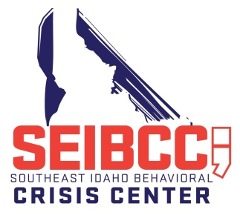
SOUTHEAST IDAHO BEHAVIORAL CRISIS CENTER ADVISORY BOARD AGENDA
October 23, 2019 at 11:00 AM
____________________________________
Meeting Location - PHT City Center, 1001 N. 7th Avenue
Training Level Conference Room

- Call to Order
- Approval of Minutes from the September 13, 2019 Meeting (action item)
- Discussion Items
  - Bannock County Fiscal Agent Report by Tiffany Olsen
  - Executive Director’s Report by Matt Hardin or Myrna Daniels
    - Donations and In-Kind Services
    - Staffing
    - Outreach
    - Review of Incident Reports
  - Service Contractor Report by DeVere Hunt or Heather Moore
    - Sustainability
    - Mid-Level Prescribing
    - Billing for Service
    - Other items
  - Department of Health and Welfare Report by Brad Baker
- Review Bylaws – proposed attendance language
- Review of Policies and Procedures
  - Guidelines, Administrative and Medical, pages 50-74 (action item)
- Other Items
  - Next Meeting Date
- Adjourn

2019
Episodes/Unique Clients

April (15-30) 92/39

May 158/87
June 186/62

July 250/77

August 207/84

September 140/58

